Job title: | Senior Project Officer
Salary: | £34,000 - £36,000 per annum, plus 3% pension contribution.
Location: | Aberdeen (hybrid working)
Hours: | 37.5hrs
Contract: | Fixed term until 31st March 2024.
Reports to: | NESCAN Hub Manager
Closing Date: | 10pm on Sunday 16th October 2022
Interviews will take place on Monday 31st October 2022.

About the NESCAN Hub
The North East Scotland Climate Action Network (NESCAN) Hub is a regional community climate action support hub, fully funded by the Scottish Government, which has grown out of a wide network of community climate action groups in Aberdeen City and Aberdeenshire.
Our vision is to contribute to the creation of a flourishing, connected and sustainable North East Scotland through the provision of dedicated training, help and support for community led climate action.

Our aims:
- To support and develop community led climate action throughout Aberdeen City and Aberdeenshire.
- To be the voice of community climate action and link into policy and decision making at a regional and national level.

For further information on NESCAN please visit our website www.nescan.org

About the role
The Senior Project Officer is responsible for ensuring the NESCAN Hub, and its aim, objectives and outcomes are delivered on time, and within scope and budget. The post holder’s role will be to ensure the Hub’s governance structure, policies and procedures are followed, including HR policies and procedures, ICT, and financial budget management. They will also provide advice, support, and guidance to the NESCAN Hub Team and NESCAN members to ensure they meet their objectives. This is a managerial role but will involve ‘on the ground’ work with the NESCAN Hub team and stakeholders, including communities and members of the public across the North East of Scotland.

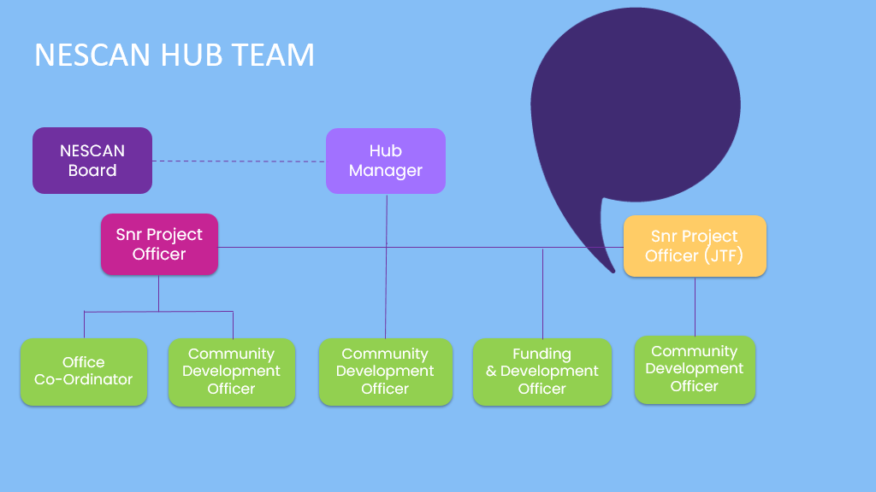

Responsibilities include but are not limited to:
- Co-create a 2023 – 2024 annual business plan with objectives and an action plan to achieve this, including milestones, timelining and indicators of success.
- Undertake research and keep the team up to date with relevant legislation and policies.
- Connect the Hub to local, regional, and national networks and act as a liaison between the Hub and local and national government bodies.
- Provide knowledge, advice, and support to the NESCAN Hub team, Board and NESCAN members.
- Build the skills and capacity of team members and community organisations by sourcing and providing practical training and educational resources.
- Chair meetings when required, including NESCAN Hub Team and NESCAN members meetings.
- Prepare and present written and verbal reports to the NESCAN Hub Manager, NESCAN Hub Board and Scottish Government when required.
- Contribute to NESCAN Hub financial budget planning and implementation.
- Plan and organise community meetings and events.
- Assist with NESCAN Hub campaigns and events as required.
- Represent NESCAN Hub at relevant meetings and events.
- Assist and provide cover for the NESCAN Hub Manager when required.
- Line management responsibilities.
- Any other duties as required to contribute to the delivery of NESCAN Hub’s vision and aims.

About you
You will have experience and knowledge in the following:
- Experience in project management.
- Experience as a budget holder, bookkeeping experience or equivalent.
- Experience hosting and facilitating meetings and workshops.
- Experience building and maintaining strong relationships and networks.
- Line management experience.
- Negotiation, managerial and leadership skills.
- Knowledge and understanding of climate change and the challenges this poses to communities within Aberdeen City and Aberdeenshire.
- Knowledge of and contacts within regional and national organisations which can provide resource and support to communities.
- Experience within the 3rd and/or public sector, especially in relation to climate change or community engagement, is desirable.

You will have the following qualities which are essential to this role:
- Excellent attention to detail and accurate record keeping.
- Excellent organisational, interpersonal and communication skills with people, at all levels.
- Ability to work autonomously and as part of a team.
- Ability to prioritise and balance your workload to meet deadlines and deliver outcomes.
- Flexibility and a ‘can do’ attitude.
- Ability to motivate and empower others.
- Passionate about sustainability, climate change, biodiversity, and community justice.

The following qualifications are required for this role:
- Undergraduate or Postgraduate qualification in a relevant subject.
- Project management qualification e.g., PRINCE2, APM, Six Sigma, etc. is desirable.
- Qualification in environmental science/management, sustainability or biodiversity is desirable.

Other requirements:
- Regular travel across Aberdeen City and Aberdeenshire applies. The postholder may be required to occasionally travel out with the region via public transport. Travel expenses will be reimbursed.
- This post will include occasional weekend and evening work. Postholders will be given at least 2 weeks’ notice for this work, where possible.

Important information regarding interviews

Interviews will take place on Monday 31st October 2022 in the James Hutton Institute, Craigiebuckler, Aberdeen. Interviews via Zoom can be arranged upon request.

How to apply
Please apply via our website www.nescan.org
If you have any questions regarding this post, please contact NESCAN Hub Manager Alison Stuart alison@nescan.org

Regrettably, we cannot accept applications from anyone who requires a work UK permit.
The closing date for applications is 10pm on Sunday 16th October 2022

Summary of Terms and Conditions of Employment

Job title: Senior Project Officer

Employer: NESCAN Hub

Salary: £34,000 - £36,000 annum pro rata plus 3% pension contribution.

Location: This post is a mix of home and office working. The postholder will be expected to come into the office based in the James Hutton Institute at least every Tuesday. Regular and extensive travel across Aberdeen City and Aberdeenshire applies. The postholder may be required to occasionally travel out with the region via public transport. Travel expenses will be reimbursed.

Hours: Working hours are 37.5 hours per week Monday to Friday. This is a flextime post with core working hours agreed between the postholder and Hub Manager. The post holder will be expected to work weekends and evenings when required and will be given a minimum of 2 weeks’ notice for this, where possible.

Contract: The post is fixed term until 31st March 2024. There is scope to extend this post for a further two years dependent on funding.

Annual leave: The NESCAN Hub offers full-time employees 35 days annual leave per annum, including public holidays, which runs from 1st April to 31st March. All leave entitlement is calculated pro-rata for part-time employees.

Other leave: Employees have contractual rights to time off for sickness, maternity and other circumstances. Employees may also take flexi-leave in hours, half days or full days to a maximum of 2 full days per calendar month.

END

